**Software Engineering Question bank for Class Test 1**

* List software characteristics.
* Draw Diagram of Layered technology approach.
* Define Software. State two types of software.

* Explain waterfall model with diagram.
* Draw and explain RAD model.
* Draw and explain prototyping model.
* Explain Spiral model with diagram.

* List any four planning principles.
* List and explain four communication practices.
* List and explain four software deployment principles. • Explain any four software engineering core principles.

* Explain the following design concept:1. Abstraction 2. Information Hiding • Explain following requirement engineering task: 1. Negotiation 2. Validation • Explain decision table with example.

* List symbol used in DFD diagram.

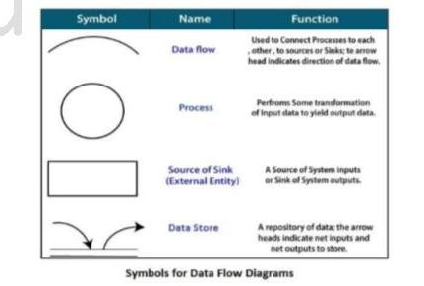

Circle: A circle (bubble) shows a process that transforms data inputs into data outputs. Data

Flow: A curved line shows the flow of data into or out of a process or data store

Data Store: A set of parallel lines shows a place for the collection of data items. A data store indicates that the data is stored which can be used at a later stage or by the other processes in a different order. The data store can have an element or group of elements.

Source or Sink: Source or Sink is an external entity and acts as a source of system inputs or sink of system outputs.

* Draw use case diagram for library management system.
* Draw use case diagram for ATM system with minimum four use case and two actors.
* **Explain decision table with example.**

Ans: Decision table is a software testing technique used to test system behaviour for different input combinations.

This is a systematic approach where the different input combinations and their corresponding system behaviour (Output) are captured in a tabular form. That is why it is also called as a **Cause-Effect table** where Cause and effects are captured for better test coverage.

Example 1: Decision Base Table for Login Screen

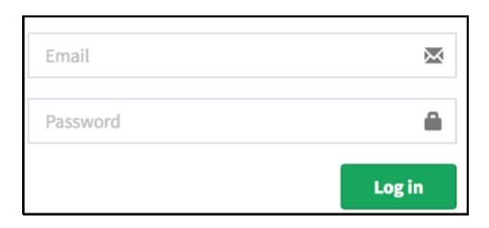

The condition is simple if the user provides correct username and password the user will be redirected to the homepage. If any of the input is wrong, an error message will be displayed.

Legend: T – Correct username/password

F – Wrong username/password

E – Error message is displayed

H – Home screen is displayed

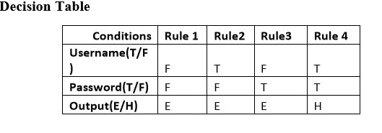

Interpretation:

Case 1 – Username and password both were wrong. The user is shown an error message.

Case 2 – Username was correct, but the password was wrong. The user is shown an error

Case 3 – Username was wrong, but the password was correct. The user is shown an error message.

Case 4 – Username and password both were correct, and the user navigated to homepage.